Redesign of UWA REV Vehicle’s GUI & Instrumentation

Marcus Pham  
20495924  
University of Western Australia

Supervisor: Prof. Thomas Braunl  
School of Electrical, Electronic and Computer Engineering  
University Of Western Australia

Submission Date:  
23/05/14

Table of Contents

Background Information 3

The Problem/Question addressed 4

Literature Review (Past Theses/related work) 5

Electric Vehicles 5

Instrumentation 5

Electric Vehicle Instrumentation 5

Holden Volt 6

Nissan Leaf 7

Tesla Roadster 7

Previous Instrumentation 7

Plan (Aim/objectives) 9

Dimming 9

Radio/Bluetooth/GPS 9

State of Charge/Distance Remaining 9

Efficiency Ball 9

General Clean-Up and General Aesthetics 10

Relocation of LCD 10

Tachometer (Hall Effect Sensor/OBD/CANBUS) 10

Timeline (GANTT Chart) 11

Preliminary Work 12

References: 13

Appendices 14

# Background Information

With the growing concerns of ozone layer depletion, and the impact of internal combustion engine vehicles (ICE) being a major factor in carbon emissions, there is a growing need to find alternative methods of transport. Although there are many schemes to limit the use of personal vehicles in use, like public transport and carpooling incentives, this is not a solution to the problem.

The UWA Renewable Energy Vehicle Project (REV) plans to ‘revolutionalise personal transport’ by building zero emission vehicles, charged from renewable sources. Currently UWA has 2 road-legal fully electrical vehicles that provides a solution to the before mentioned problem [1].

The REV Eco was the first plug-in electric conversion project that was started and completed in 2008. The REV Eco was originally a Hyundai Getz 2008, which had been converted to an electric vehicle by replacing the internal combustion engine with a electric drive motor, batteries wiring and instrumentation [2].

The second conversion made by UWA to convert an ICE to electric drive vehicle is the REV Racer. This car was based on a 2002 Lotus Elise S2 and like the Getz involved complete replacement of the ICE by a motor controller, batteries and instrumentation [3].

In any vehicle, the first point of person to machine interaction is to the instrumentation inside of the vehicle’s cockpit. This instrumentation can vary from vehicle to vehicle but the interface must be there to inform the user of current statistics as well as any problems or issues present. In an electric vehicle the importance of the instrumentation, especially the user interface, is even more important as statistics on battery charge, battery condition and distance remaining are critical to the user.

However, the instrumentation has to be carefully designed to give the user sufficient information to gauge the state of the vehicle whilst not overloading the user, causing a distraction from the actual driving of the vehicle. Hence the interface is integral with the safety of a vehicle.

Though the cars have been up and running for the past few years, the instrumentation of both cars has not yet been implemented perfectly. There are a still a few missing components that are required in the vehicle as well as user interaction issues and information overloading on the main page.

# The Problem/Question addressed

Previously, there have been implementations of a user interface for both the REV Racer and the REV Eco. Through the years, the interface has changed in both aesthetics as well as functionality. The reasons for this vary greatly, from changes in technology to differences in personal taste.

However, as of the current time, the instrumentation is still not ideal and still has a few problems in the design. There are still a few things that need to be added to enable better communication between the driver and the vehicle and a few components that should be less emphasized to increase road safety.

The main focus of this project is to redesign the user interface and the dash to be more clear, concise, ergonomic as well as containing more information and statistics.

Most importantly is to get a working tachometer in both the Lotus and the Getz. As of the current moment, there is no working tachometer in the cars, which limits the use of the manual gearbox in both cars. The absence of a tachometer makes it very difficult to change gears, which is integral for operating a manual transmission car. Though in an electric vehicle the range of rpm in the motor controller is greater, this still does not allow for full use of the vehicle’s torque. If full use of the gearbox is enabled, the rate of acceleration as well as overall efficiency would be increased.

Additionally, it would be even more functional for the cars to have a working tachometer that works independent of the user interface. This would create a much more robust system by not being reliant on the user interface being functional. Also, the use of an independent tachometer would allow more room on the graphical user interface (GUI) to use for other information.

Other aims for the project include: redesign of the GUI to be more easily accessed, the current GUI has very small icons making it very difficult to choose options from the menu; redesign the GUI to emphasize more important information and minimize more unimportant or overly descriptive elements, like telemetry; redesign to make the GUI more visible under varying levels of light; whist adding more additional information on the interface and increase functionality and robustness.

Additionally, relocation of the LCD screen is required in the cars, especially the Lotus. This is to enable easier access to the LCD and increasing safety by lowering the risk of the vehicle user needing to reach over to access important information.

# Literature Review (Past Theses/related work)

## Electric Vehicles

Electric vehicles have been present since the dawn of the vehicle. The idea of a electricity driven vehicle has been around since the early 1800’s. However due various problems and limitations of an electric motor, in comparison with an internal combustion engine, the electric vehicle did lost popularity since the 20th century. The main contributing factor to this is the range limitation on battery-powered vehicles as well as the low top speed offered at the time.

## Instrumentation

In any given vehicle, there is a need to display and inform the user of current diagnostics of the vehicle. Over the years, there have been many changes in the display mode and method with regards to vehicle instrumentation. Improvements and upgrades have evolved over the years through improvements of technology and changing views on the required elements.

The basic requirements that are present in almost every modern vehicle is: a speedometer, tachometer, odometer, fuel level gauge, water temperature gauge and warning indicators.

However, no two vehicle instrumentation are alike. Though there are some basic requirements that are needed in every vehicle, there are differences in the specifics in every car.

The need for a specialized instrumentation is important due to differing needs and desires of the car and user. For example, in an economy car, like a Mazda 3, then the instrument panel and cluster reflects on the needs and requirements of a family workhorse. Hence the panel consists of a the basics plus some comfort features like outside temp level, an entertainment unit, a fuel economy reading [See Appendix 1].

This is in contrast to a more sports/race-oriented vehicle, like a Honda Integra Type R. The instrument panel in a sports vehicle is generally much more simple, as to keep the main attention of the driver on the road, however there are some extras associated with this. Oil temperature, oil pressure, fuel-to-air ratio gauges are normally present in these cars so that drivers can have instantaneous access to important vehicle diagnostics rather than just a warning lamp [See Appendix 2].

## Electric Vehicle Instrumentation

Electric vehicles are no exception to the rule of having a specialized instrument panel. Though the mechanics of an electric vehicle is arguable simpler than that of an internal combustion engine, the instrument panel in an electric in general needs to be a bit more involved. Being able to see the current state of the vehicle is very important in electric vehicles, like being able to see current state of charge, battery status and distance remaining, makes the design of an instrument panel very difficult. There needs to be a balance between simplicity and the amount of information offered to the road user.

Some car makes have already implemented their own mass produced full electric vehicles and as such have created many differing instrument panels with slightly different information being displayed in each.

In general, there are many similarities to an ICE vehicle in terms of the vehicle instrumentation. Both cars require a speedometer and basic warning alerts. Also similar is the state of charge level in an electric vehicle in comparison to an ICE vehicle.

However there are a few differences that are common in most electric vehicle instrumentation that is different to an ICE vehicle. Most electric vehicles are automatic, due to the nature of the electric motor, and hence don’t require a tachometer as gear changes are not required. Distance remaining estimates are critically important in electric vehicles due to the difficulty in recharging the batteries in contrast to re-fueling an ICE. Hence almost all electric vehicles are equipped with these whereas this trend has only started appearing on ICE vehicles. Additionally, most EVs have multiple instrument panels, usually involving a main dash and a secondary interface to get additional details.

## Holden Volt

The Holden/Chevrolet Volt is one of the few electric vehicles that are available for road use at the moment. As with most EVs, the Volt has 2 LCDs to display information. One displays more important, on the road information, the other containing additional information of the vehicle.

The main dash consists of a speedometer, a state of charge gauge, warning indicators, an odometer and distance remaining indicator. However one of the special unique features of the Volt main dash include the ‘economy ball’. This ‘ball’ visibly shows the user how efficiently the driver is driving. The ball shifts up/down from the centre and changes colour from green to yellow to red upon hard braking or acceleration. This has a benefit on the driver as the user is now able to see how they should be driving to increase distance and efficiency, of which is critically important to an electric vehicle [Appendix 3].

The centre console consists of another LCD screen that display less urgent information. This screen shows the amount of charge used, current ambient temperature, the time, the level of charge used versus fuel consumption and long term averages for consumption. This console also acts as a GPS, entertainment unit and the climate control display when flipped to the corresponding display. A useful statistic that the Volt shows is the overall efficiency of the trip at the current time. This gives you a percentage value on how efficient your driving style, climate control values are. The centre console also shows a visual representation of how power is transmitted to the drivetrain, i.e. Regenerative braking under deceleration or battery usage under acceleration.

The Volt’s instrumentation is very involved and the method of control of the centre console, touch buttons, sometimes makes it difficult to choose menus. There have also been many complaints on this method of input as the location of the buttons disallows users to rest their hand on the centre console when selecting menus, often leading to accidental button presses. Also, there are a few other areas that could benefit from improvement with regards to the instrumentation.

There is an overabundance of information to the user at times and can be a bit of a distraction to the road user on certain menus. There is also a few elements that are not required, like the visual of the power transmission and the reading of tire pressure. Additionally there are elements that could be useful to be included, like current battery condition and voltage levels and statements of actual current draw and levels.

## Nissan Leaf

The Nissan Leaf is another electric vehicle that has been successful in production. The Leaf’s instrumentation is very much similar to the Volt with a few differences. As with the Volt, the main cluster (inclusive of the mini LCD above the steering wheel) includes a speedometer, odometer and state of charge gauges as well as warning indicators [Appendix 4].

Different to the Volt is the battery temperature gauge, the time to fully charge on the main cluster (which is on the secondary LCD in the Volt). The Leaf also has a power meter, which essentially shows a visual image of the current flow in the car, right for current draw and left for power regeneration.

Similar to the Volt’s ‘economy ball’, the Leaf has an economy meter which increases when driving efficiently. However, this only shows the economy for the entire trip and not instantaneously as with the Volt.

## Tesla Roadster

The Tesla Roadster is another EV that has been key to the development of EVs. The Roadster is different from the Leaf and the Volt in that it is a more sports oriented vehicle. The Roadster again has many similarities to the Volt and Leaf except that the overall design of the main cluster is much simpler to allow the driver to focus on the driving elements rather than the internal electrics. Additionally the speedometer and the current gauges are analog, which allows a larger amount of readings than a whole number speed. Additionally, many of the optional information that is available on the other two electric cars is removed, like efficiency gauges and energy usage displays [Appendix 5].

## Previous Instrumentation

Since the conversion of the Getz to full electric, there has been constant revision to the instrumentation panel in the REV vehicles.

The first implementation of a user interface was from Michelle Ovens in 2008 [4]. Ovens created a sound working instrument panel. This consisted of converting the existing fuel gauge to display the current state of charge using the coulomb counting technique and sending the result to the Eyebot and then to the cluster via PWM. Ovens also managed to get a working tachometer from the motor’s hall effect sensors as well as speed and distance estimates.

The remaining implementations have since been phased out by the removal of the Eyebot and the introduction of the Raspberry Pi.

In 2009 Varma, further improved upon the design of the instrumentation in the Getz as well as redesign the instrument panel for the newly converted Lotus Elise [5]. Main updates include a breakout box to enable easier access and flexibility in the design. Extra features were also included like radio and heater components and G-Force Tab.

However, most of the updates are outdated due to the replacement of the Eyebot to the Raspberry Pi.

2010 had Thomas Walter working on the instrumentation of the cars [6]. His input to the development of the instrumentation was the conversion to use QT as the base programming language. QT is a very portable and robust language that can easily be compiled on any platform. This allows it to be run on many different hardware. Walter also added on extra features including logging and battery cell monitoring.

In 2011 Tyler additionally expanded on Walter’s code and added extra features like enhanced logging, telemetry and a Main Roads panel [7]. Additionally the implementation of engine sound was done but is phased out by the introduction of the Raspberry Pi.

Tyler also began implementation of a working tachometer in the Lotus, through CANBUS, but did not manage to complete this task due to damage to the car. Also improvements were made in calculating the current state of charge.

Gabriel Feng is the latest member to make changes to the user interface [8]. Contributions made include complete conversion to the more portable Raspberry Pi and reimplementation’s of the software to suit the new base. However due to this change, many previous implementations were unusable and much functionality has been lost.

# Plan (Aim/objectives)

Upon review of previous implementations of vehicle instrumentation as well as the implementations done by previous students on the REV project, a number of areas need to be implemented/changed as well as additional elements that need to be added.

This project will aim to implement a clear, concise and informative GUI on the LCD using the Raspberry Pi platform using QT. The instrumentation must have sufficient information, be robust, and minimize unnecessary information.

From review of the previous work on the instrumentation, and personal use of the system, the following areas will need to be modified.

## Dimming

The current user interface is quite difficult to see during the daytime yet is too bright during night-time conditions. This is due partly to the colour scheme and and mechanism of how to adjust the brightness of the LCD.

The method to do this is to link up the Raspberry Pi with a digital input that adjusts the brightness of the LCD with respect to the parker lights being on/off. Other options were to install light sensors on the vehicles, however this would prove to be more costly and add unrequired complexity to the system.

## Radio/Bluetooth/GPS

These additional extras have been lost after the conversion to the Raspberry Pi. Secondary aims will be to implement a working Radio/Bluetooth and mapping system on the Raspberry Pi.

## State of Charge/Distance Remaining

The current method to calculate the remaining distance is quite basic and does not give an accurate reading for the road user.

Aims will be to obtain output from the TBS to the Raspberry Pi and store data to gain an approximate distance calculator, based on the current driving style of the user.

## Efficiency Ball

The efficiency ball and efficiency reviews from both the Volt and the Leaf have been quite successful. Additionally, the implementation of an economy gauge and overall efficiency improves the driver’s willingness to drive efficiently as well as enabling the driver to know how much they are saving. Being an electric vehicle, the need to be efficient is critical and as such some implementation of some meter to gauge the driver’s efficiency is needed in the REV vehicles.

Implementation of an efficiency gauge can be done by gauging the level of current draw/throttle position. Alternatively the rate of acceleration can be used to gauge the instantaneous efficiency of the vehicle. Additional research is required to assess how Holden programs the efficiency ball on the Volt.

## General Clean-Up and General Aesthetics

There have been complaints regarding the current implementation of the instrumentation. Main complaints have been due to robustness, the program only works some of the time, as well as difficulty in selecting menu buttons, due to the small size.

The following criteria will be in place when designing a new interface:

* Larger/more distinct buttons
* Display of Actual Voltage
* Larger display for distance remaining rather than % value
* Clearer display for current, include positive/negative drain
* More EV-specific warning alerts, eg. Low minimum cell voltage

## Relocation of LCD

The location of the touch screen LCD is key to the safety of the driver and passengers. The current location of the LCD in the cars, especially the Lotus, makes it very difficult to access and creating a hazard on the road.

Feng has demonstrated possible ideal areas for placing the LCD monitor and solutions to this will be implemented.

## Tachometer (Hall Effect Sensor/OBD/CANBUS)

One major aspect that will be focuses on is the implementation of an independently working tachometer. The need for a tachometer in the manual gearbox Lotus and Getz have been long overdue in order to change gears.

A reimplementation of the method by Ovens in the Getz will be attempted.

In the Lotus, the implementation of the tachometer will be done via the CAN Bus output from the UQM motor in the Lotus. This however requires a CAN to alanalog converter as discussed by Tyler.

# Timeline (GANTT Chart)

The Project is to be completed in 2 main sections: Semester 1 to research and get familiar with the language/code and Mid year break and first half of semester 2 to implement and modify the user interface and tachometer.

The initial draft of the Section 1 timeline was:

wk3 = get qtcreator to compile and build/deploy to rPi via OSX

wk4 = call EV works for info on tacho, research on economy ball

wk5 = read up on previous theses on Lotus/Getz

wk6 = work on understanding UI and functionality

wk7 = continue

wk8 = continue (mid-sems)

wk9 = Study Break

wk10 = Start on project proposal write up

wk11 = Finish up project proposal

wk12 = Finalise project proposal

wk13 = start on phase 2 (new ideas/finish up UI)

The majority of the tasks in Phase 1 are complete. Extra research, however, is required as extra depth is needed to implement the project soundly.

Below is a Gantt chart representing the tasks and their respective allocated times and finish points:

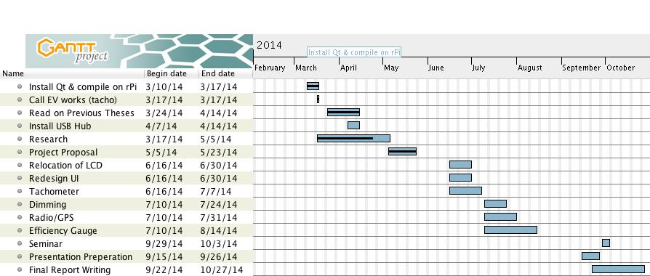

# Preliminary Work

Due to the transition to a new programming language, there has been a need to learn and adapt to the new conventions of QT. Additionally problems were present in compiling and installing QT on the computer. This has been overcome and a running version of the interface can be compiled and run on any Raspberry Pi.

Additionally, the previous code has been read and modifications to the code have begun. Drafts of the new interface have been written up to meet the specifications of the vehicles.

The powered USB hub for the Getz has been wired up and is awaiting final installation into the Getz.

Sound testing for the Getz is planned for the next few weeks due to difficulty in accessing the ICE engine Getz.

Finally, the road testing of the Holden Volt was completed prior to the start of semester, and the report has been written up.

# References:

[1] T. Braunl. (2013). The *REV Project* [Online]. Available: [http://therevproject.com/](http://therevproject.com/vehicles/economy.php)

[2] T. Braunl. (2013). *REV Eco* [Online]. Available: <http://therevproject.com/vehicles/economy.php>

[3] T. Braunl. (2013). *REV Racer* [Online]. Available: <http://therevproject.com/vehicles/performance.php>

[4] M. Ovens, “Instrumentation for the REV Project, an Electric Vehicle Conversion,” M.S. Thesis, Dept. Elect. Eng., UWA, Perth, WA, 2008.

[5] D. Varma, “Renewable Energy Vehicle Instrumentation: Graphical User Interface and Black Box,” M.S. Thesis, Dept. Elect. Eng., UWA, Perth, WA, 2009.

[6] T. Walter, “Development of a User Interface for Electric Cars,” M.S. Thesis, Institute of Parallel and Distributed Systems, University of Stuttgart, Stuttgart, 2010.

[7] M. Tyler, “REV Performance Vehicle Instrumentation,” M.S. Thesis, Dept. Elect. Eng., UWA, Perth, WA, 2011.

[8] G. Feng, “Renewable Energy Vehicles’ User Interface,” M.S. Thesis, Dept. Elect. Eng., UWA, Perth, WA, 2013.

[9] S. Puma. (2010, August 3) Nissan Test Drive and First Impressions [Online]. Available: <http://cdn8.triplepundit.com/wp-content/uploads/2010/07/nissan-leaf-ev-018_100226074_l.jpg>

[9] Ritchie. (2011, January 17) Nissan Tesla Motors: Charging Up the Car Market [Online]. Available: <http://ritchiesroom.com/tag/tesla-roadster/>

# Appendices

## Appendix 1 (Mazda 3)

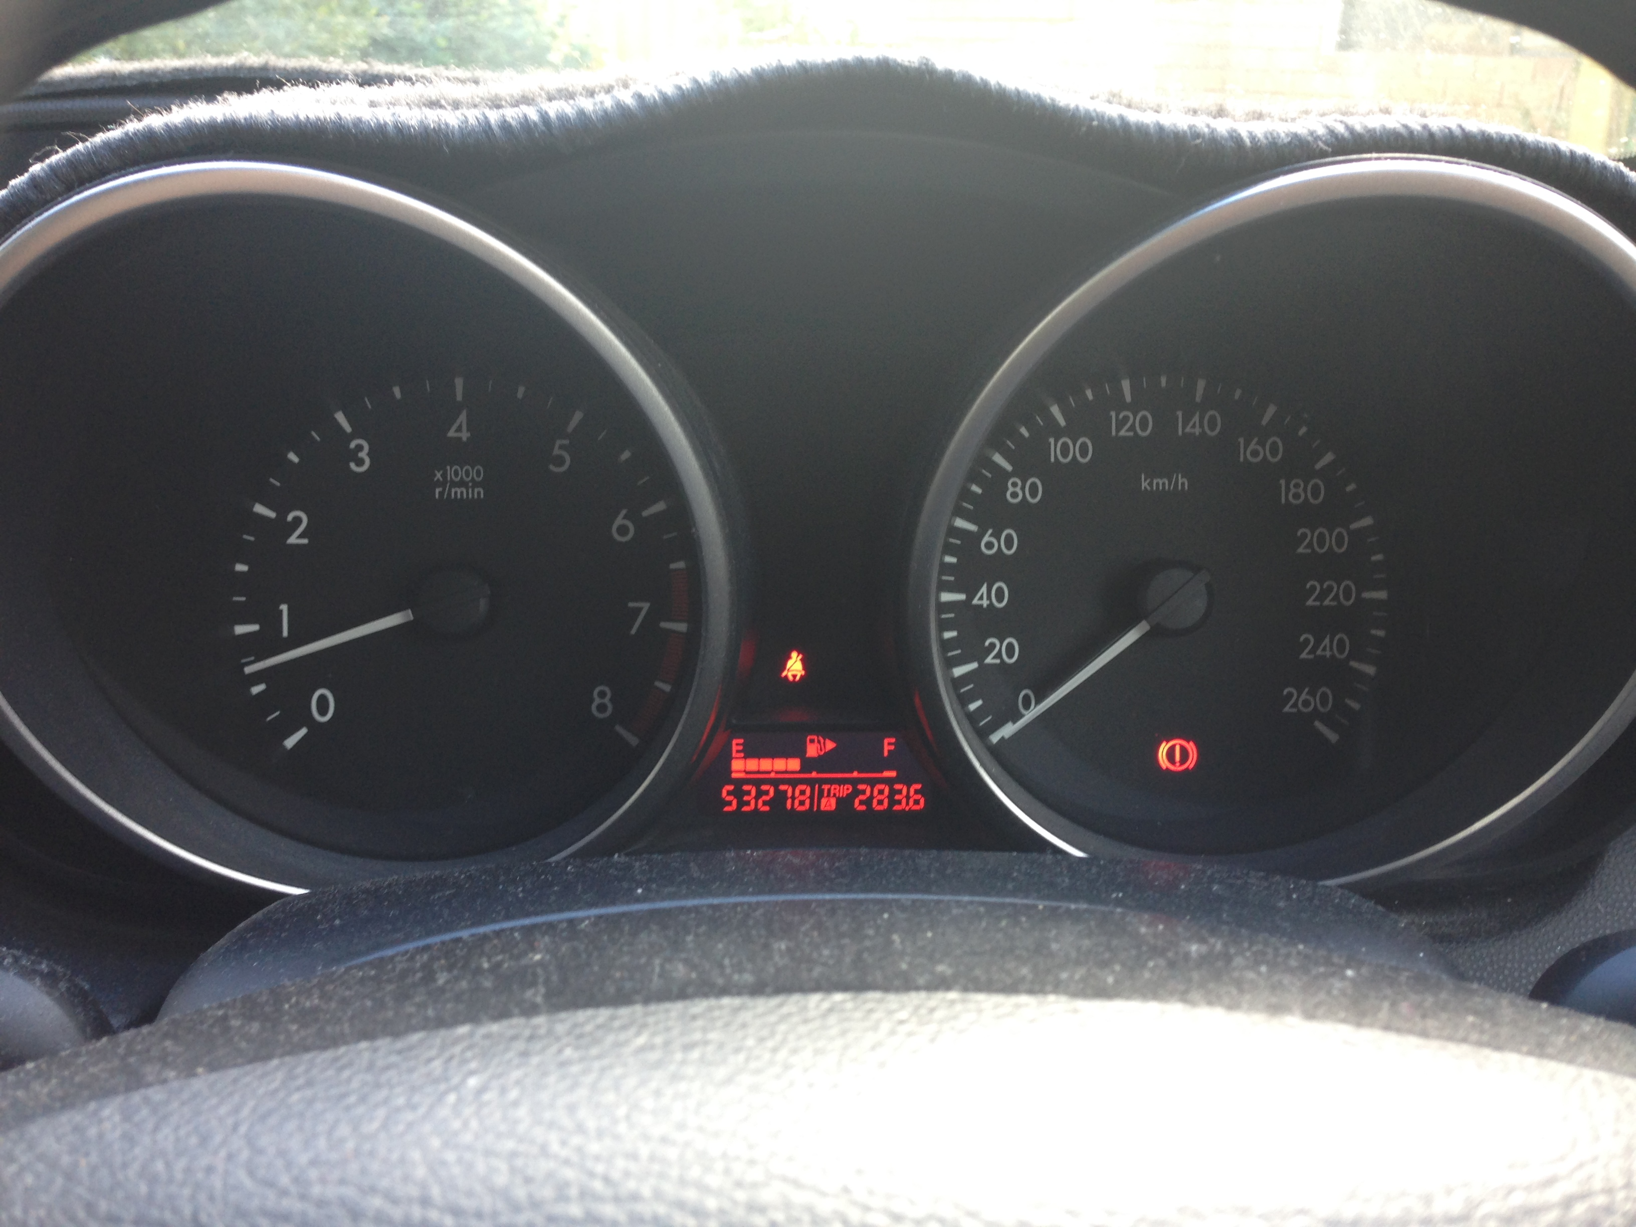

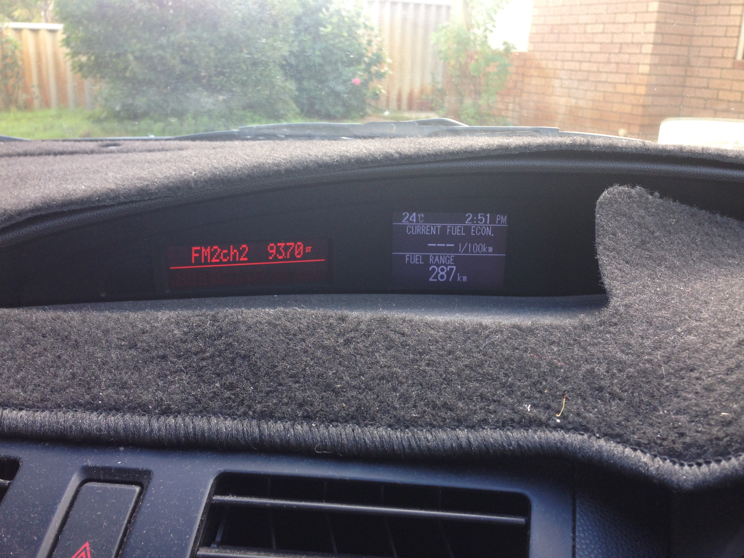

## Appendix 2 (Honda Integra)

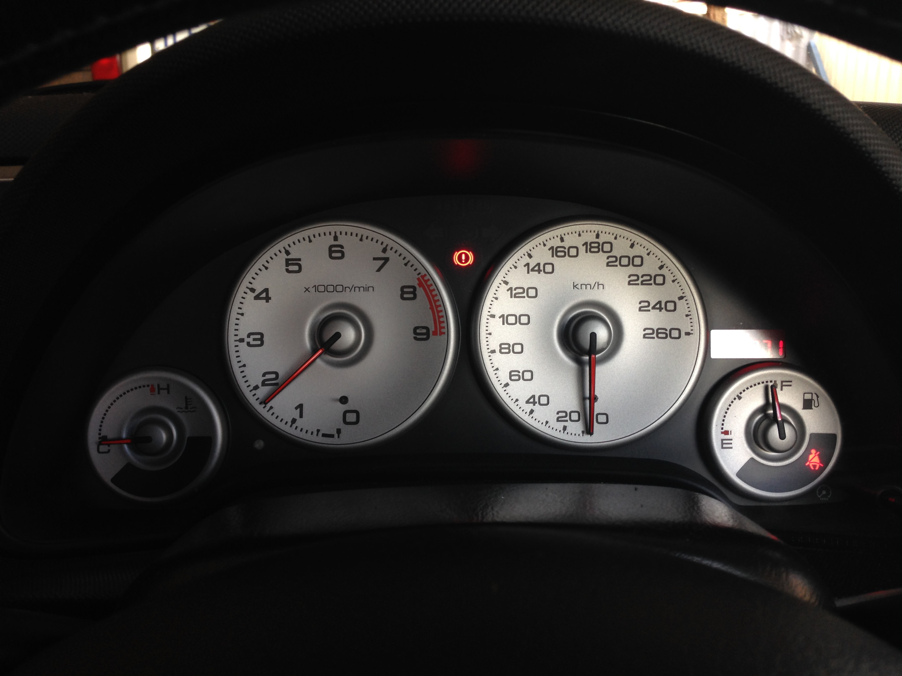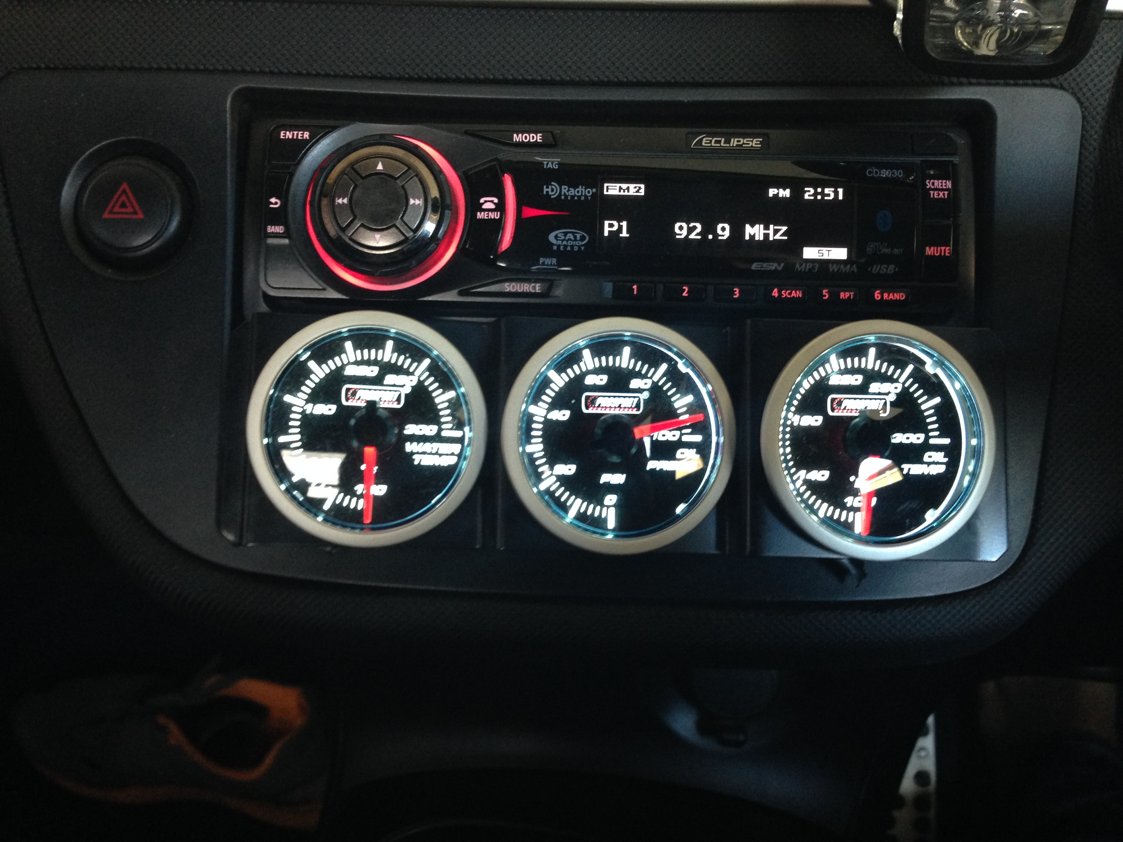

## Appendix 3 (Holden Volt)

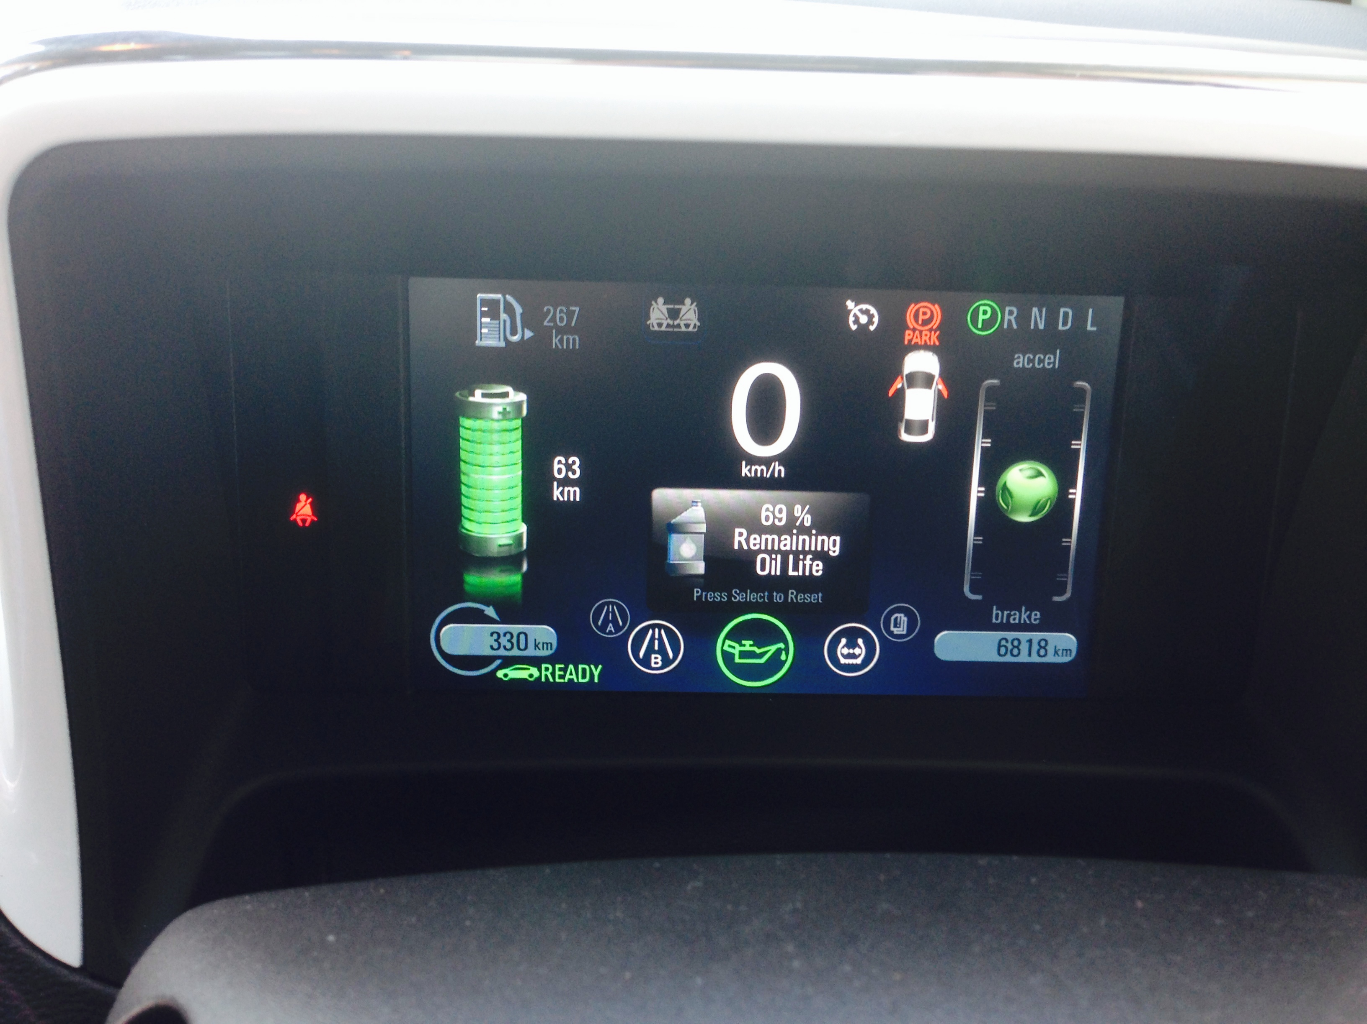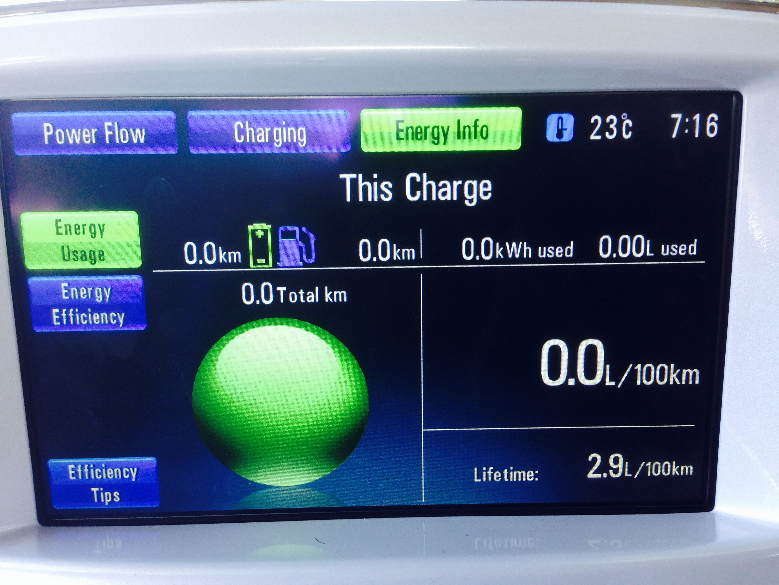

## Appendix 4 (Nissan Leaf) [9]

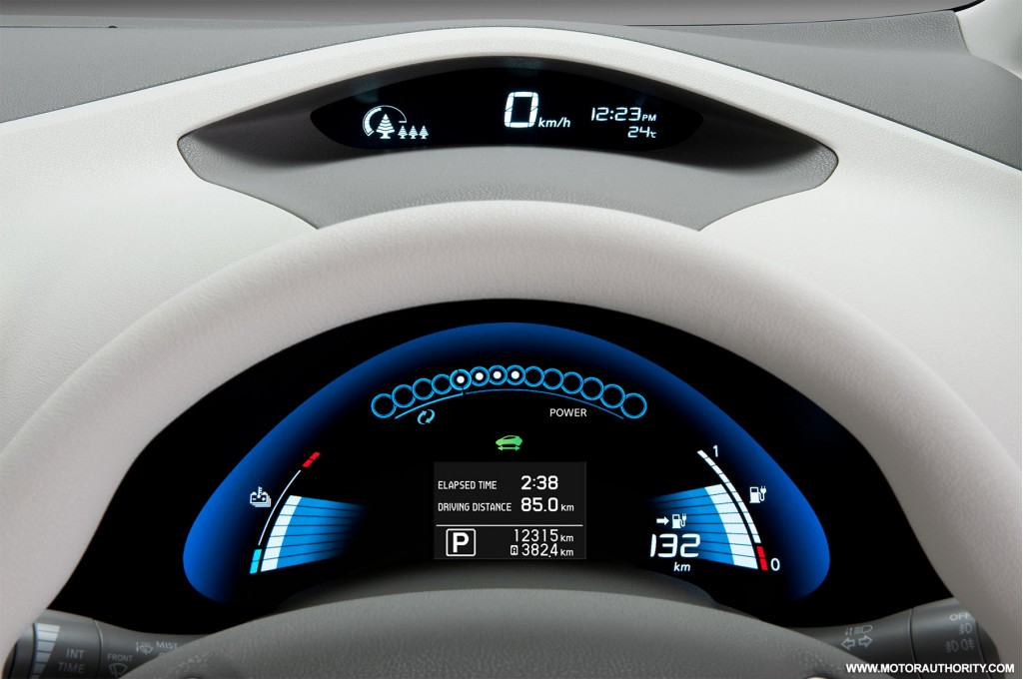

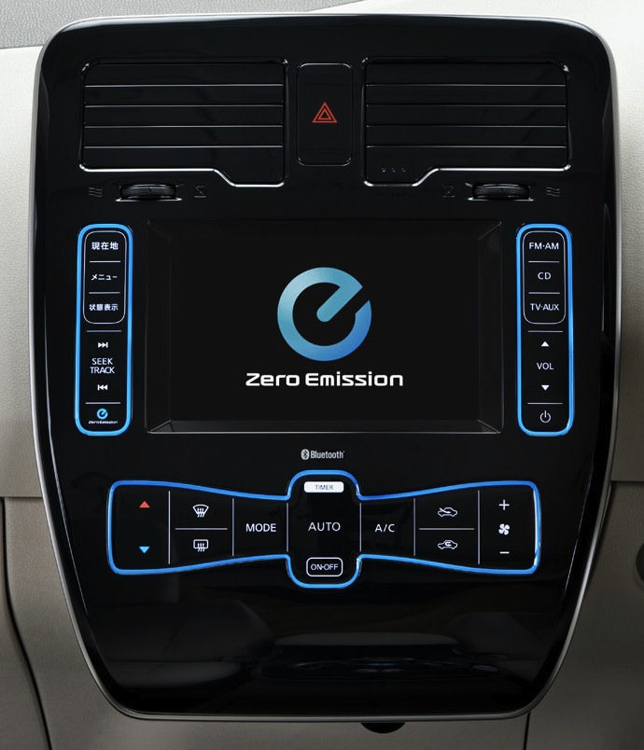

## Appendix 5 (Tesla Roadster) [10]

